Exp No : 6 Date : 28-03-2019
SHELL PROGRAMMING – 2 A

Aim :
To practice various shell scripting programs

Program :

Question 1 :-
Write a shell script that displays a special listing showing the permissions, size filename and last modification time of filename supplied as arguments. Provide suitable headers using the printf command.

Algorithm :
1 Read argument
2 Save the permission, modification time, size of a file and file name into different variables.
3 Display assigned variables with suitable headers

Program :
file=$1
if [ ! -f $file ] ; then
echo "File is not present"
else
permissions="$(ls -l $file | awk '{print $1}')"
size="$(du -h $file | awk {'print $1'})"
lastmod="$(ls -l $file | awk '{print $7" "$6" "$8}')"
echo "File name : $file"
echo "File Size : $size"
echo "File permissions : $permissions"
echo "Last modified : $lastmod"
fi

Output :
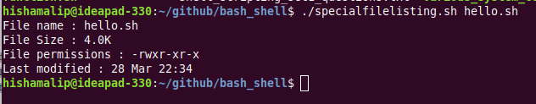
------------------------------------------------------------------------------------------------------------------------

Question 2 :-
Write a script that compares two directories dir1 and dir2(supplied as arguments) and copies to dir1 from dir2 every file that is not present in dir1.

Algorithm :
1 Read two arguments
2 Save list of files in dir1 and dir2 to two different variables dir1_files and dir2_files
3 while read i from dir1_files
4 while read j from dir2_files
5 if j != i
then copy file in the variable j to dir1 without overwriting
6 end if
7 end while
8 end while

Program :
dir1=$1
dir2=$2
if [ $# -ne 2 ] ; then
echo "invalide number of arguments"
elif [ ! -d $dir1 ] && [ ! -d $dir2 ] ; then
echo "Directory '$dir1' and '$dir2' is not present"
elif [ ! -d $dir1 ] ; then
echo "Directory '$dir1' is not present"
elif [ ! -d $dir2 ] ; then
echo "Directory '$dir2' is not present"
else
ls $dir1 > dir1_files
ls $dir2 > dir2_files
while read i ; do
while read j ; do
if [ $j != $i ] ; then
flag=1
if [ $flag -eq 1 ] ; then
cp -n $dir2/$j $dir1/
fi
fi
done < dir2_files
done < dir1_files
echo "Files in $dir2 that is not present in $dir is copied to $dir1"
fi

Output :
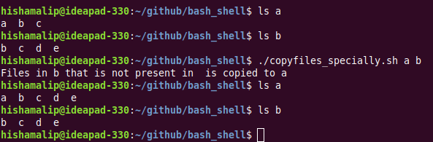

Question 3 :-
Write a shell script that accepts two file names as arguments, checks if the permissions for these files are identical and if the permissions are identical,output common permissions and otherwise output each file name followed by its permissions.

Algorithm :
1 Read two arguments
2 Save permission of first file into a variable and second file into another variable
3 if check both variables are same , then
print “identical file permissions”
4 else print permissions of both files
5 End if

Program :
file1=$1
file2=$2
if [ $# -ne 2 ] ; then
echo "Invalide number of arguments"
elif [ ! -f $file1 ] && [ ! -f $file2 ] ; then
echo "File '$file1' and '$file2' is not present in the directory"
elif [ ! -f $file1 ] ; then
echo "File '$file1' is not present in the directory"
elif [ ! -f $file2 ] ; then
echo "File '$file2' is not present in the directory"
else
file1_permission="$(ls -l $file1 | awk {'print $1'})"
file2_permission="$(ls -l $file2 | awk {'print $1'})"
if [ $file1_permission = $file2_permission ] ; then
echo "Permissions are identical : $file1_permission"
else
echo "File permissions are not identical"
echo "$file1 : $file1_permission"
echo "$file2 : $file2_permission"
fi
fi

Output :
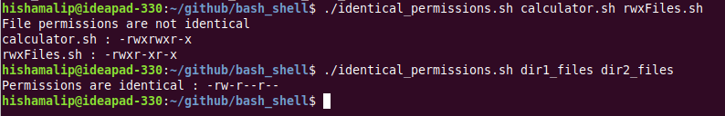

Question 4 :-
Write a shell script which receives two file names as arguments. It should check whether the two file contents are same or not. If they are same then second file should be deleted.

Algorithm :
1 Read arguments
2 Save the contents of both files into two variables a and b
3 if check a = b , then
delete second file
4 else print “different file contents”
5 end if

Program :
file=$1
file1=$1
file2=$2
if [ $# -ne 2 ] ; then
echo "Invalide number of arguments"
elif [ ! -f $file1 ] && [ ! -f $file2 ] ; then
echo "File '$file1' and '$file2' is not present in the directory"
elif [ ! -f $file1 ] ; then
echo "File '$file1' is not present in the directory"
elif [ ! -f $file2 ] ; then
echo "File '$file2' is not present in the directory"
else
file1_cont=$(cat $file1)
file2_cont=$(cat $file2)
if [ $file1_cont = $file2_cont ] ; then
echo "File $file2 is deleted"
rm $file2
else
echo "Files have different contents"
fi
fi
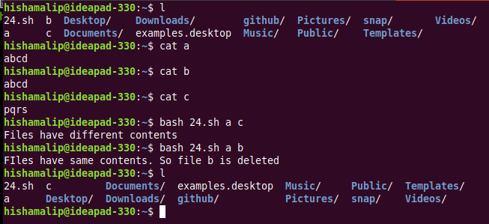
Output :

Question 5 :-
Write a shell script that, given a file name as the argument will count vowels, blank spaces, characters, number of line and symbols.

Algorithm :
1 Read argument
2 Read file and calculate number of vowels, charachters, lines, blank spaces and symbols
3 Save results into variables
4 Display number of vowels, charachters, lines, blank spaces and symbols with suitable headers.

Program :
if [ $# -eq 0 ] ; then
echo "Give a file name as argument"
elif [ $# -gt 1 ] ; then
echo "Invalid, give only one argument"
elif [ ! -f $1 ] ; then
echo "File '$1' not found"
else
blank_space=$(grep -c '^$' $1)
vowels=$(grep -i -o "[aeiou]" $1 | wc -l)
symbols=$(grep -i -o "[!@#$%^&*()+-<>]" $1 | wc -l)
chars=$(cat $1 | wc -c)
lines=$(cat $1 | wc -l)
echo "Charachter : $chars"
echo "Number of lines : $lines"
echo "Blank spaces : $blank_space"
echo "Vowels : $vowels"
fi

Output :
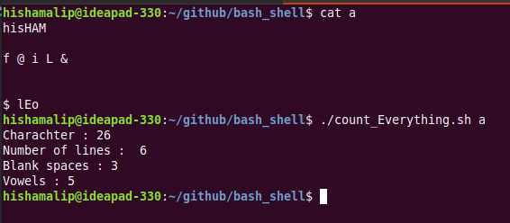

Result :
Practiced various shell scripting programs and output is verified.

